WEEK 2.3 ASSIGNMENT

1: Word Frequency from Text File
❖ Scenario:
You are analyzing log files for keyword frequency.
❖ Task:
Use Gemini to generate Python code that reads a text file and counts word
frequency, then explains the code

CODE:
def count_word_frequency(file_path):
word_count = {}
with open(file_path, "r") as file:
for line in file:
line = line.lower()
words = line.split()
for word in words:
word = word.strip(".,!?;:\"()[]{}")
if word in word_count:
word_count[word] += 1
else:
word_count[word] = 1

return word_count
file_path = "input.txt"
result = count_word_frequency(file_path)
print("Word Frequency Count:")
for word, count in result.items():
print(word, ":", count)
OUTPUT:
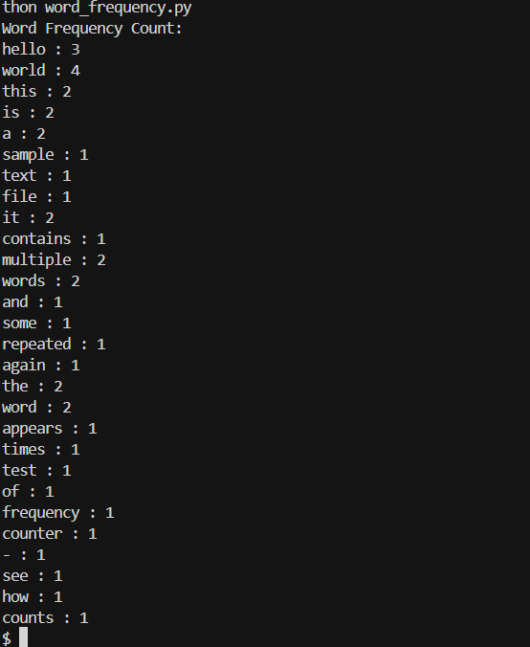

Task 2: File Operations Using Cursor AI
❖ Scenario:
You are automating basic file operations.
❖ Task:
Use Cursor AI to generate a program that:
➢ Creates a text file
➢ Writes sample text
➢ Reads and displays the content
CODE:
# 1. Create a text file and write sample text
with open("sample.txt", "w") as file:
file.write("Hello, this is a sample file.\n")
file.write("This file is created using Cursor AI.\n")
# 2. Read and display the file content
with open("sample.txt", "r") as file:
content = file.read()
print("File Content:")
print(content)
OUTPUT:
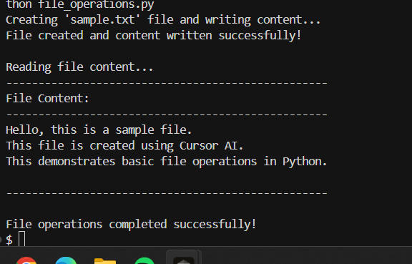

Task 3: CSV Data Analysis
❖ Scenario:
You are processing structured data from a CSV file.
❖ Task:
Use Gemini in Colab to read a CSV file and calculate mean, min, and max.

CODE:
import pandas as pd

# Read the CSV file
data = pd.read_csv("data.csv")

# Calculate statistics
mean_values = data.mean()
min_values = data.min()
max_values = data.max()
print("Mean Values:")
print(mean_values)
print("\nMinimum Values:")
print(min_values)
print("\nMaximum Values:")
OUTPUT:
print(max_values)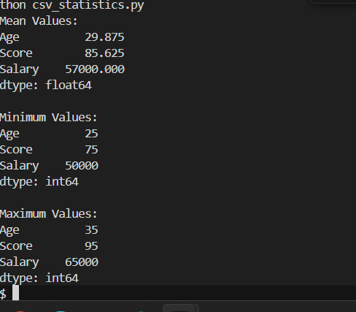

Task 4: Sorting Lists – Manual vs Built-in
❖ Scenario:
You are reviewing algorithm choices for efficiency.
❖ Task:
Use Gemini to generate:
➢ Bubble sort
➢ Python’s built-in sort()
➢ Compare both implementations.
CODE:
def bubble_sort(arr):
n = len(arr)
for i in range(n):
for j in range(0, n - i - 1):
if arr[j] > arr[j + 1]:
# Swap elements
arr[j], arr[j + 1] = arr[j + 1], arr[j]
return arr

numbers = [5, 3, 8, 4, 2]
print("Bubble Sort Result:", bubble_sort(numbers.copy()))
numbers = [5, 3, 8, 4, 2]
numbers.sort()
print("Built-in Sort Result:", numbers)

OUTPUT:
